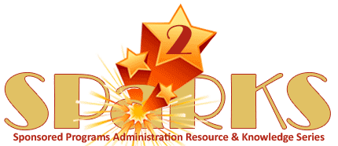

Module 4: Conflict of Interest (COI) and Research Integrity

July 17, 2013
Instructor: | Phone: | E-Mail:
Griselle Báez-Muñoz | 823-5173 | Griselle.Baez-Munoz@ucf.edu

Module Description
Conflict of Interest (COI) and Research Integrity

Module Overview
The purpose of this module is to examine the procedures and application of Conflict of Interest (COI) and Research Integrity. The importance of understanding the university regulations and policies will be discussed, as well as a review of the internal university processes to capture and review COI disclosure actions and to promote responsible conduct of research at UCF.

Module Objectives

- Participants will gain a better understanding of federal, state and university regulations associated to Conflict of Interest (COI) and Research Integrity.
- Participants will be able to distinguish between the responsibilities of ORC’s Pre-Award Services and Post Award Services actions in regard to COI disclosure submissions by investigators as they relate to DHHS/PHS & NIH funding as well as other agencies that adopted the revised FCOI regulation.
- Participants will have a better understanding of federal and university requirements associated to completion of Responsible Conduct of Research (RCR) Training and a general knowledge of the nine (9) instructional cores of RCR.
- By the end of this module, participants will gain a general knowledge of the terms associated to Research Misconduct and with the proceedings involved in the review of an allegation of research misconduct.

